Seaculture
- Maxima Project
  - Describe the proposed new arrangement with Maxima Group?
Seaculture will support the delivery of key aquaculture activities in the Kimberely & Pilbara regions to assist Maxima in re-activating their asset portfolio. This includes industry engagement with organisations such as DPIRD, ACWA, DBCA, KLC, local pearling operators and other proponents interested in aquaculture in the region.

  - How and why does this arrangement align with Seaculture’s activities and why?
Seaculture is looking at project opportunities both in the Kimberely & Pilbara where Maxima has existing aquaculture assets (i.e. boats, water leases, ropes/ lines) and community relationships (i.e. Arly mine traditional owner consortium, KLC) which can be leveraged to accelerate our commercialisation. For example, in the Kimberely Maxima have land-based and ocean based assets near Koolan Island, a decommissioned mining site currently undergoing rehabilitation. Maxima have an existing relationship with the traditional owner organisation (Jilinya Remote Services) who are currently being engaged to undertake rehabilitation activities on the island. Through this relationship with Maxima, Jilinya have enquired with SeaCulture how our seaweed derived soil product could be used as apart of their rehabilitation efforts. Another example is the pearling leases in the Pilbara, with our paid trials planned for later this year with BHP, Seaculture will need access to an ocean asset to grow local seaweed for paid field trials. Through conversations with DPIRD, having the environmental baseline data for a specific lease area can allow SeaCulture to accelerate our own approvals to gain an aquaculture exemption or lease in the area.

Maxima is also focusing on regional economic development through aquaculture in the Kimberely region which will include training programs, government lobbying, consortium establishments and identification of new opportunities (i.e. seaweed), all of which are critical of SeaCulture’s long-term successful operations in North Australia.

  - What proportion of founder-time will be dedicated to this engagement and for how long?
Maxima is entering a “pilot” year for 2027 to build on existing and new partnerships and reactivate their assets. At this stage, Seaculture is willing to commit to supporting Maxima during this pilot year (i.e. for the next 12 months) before reassessing the strategic alignment.

Core activities which are directly related to Maxima’s operation takes approximately 20 hours a month, whereas mutually beneficial time such as industry and government engagement will take approximately 30 hours a month, note that this include activities such as attending events/ conferences/ industry workshops.

  - What mechanisms will be put in place to ensure core Seaculture business can be prioritised?
The Maxima team is small meaning all work is self-managed and delivered to SeaCulture personally established schedule. This means time spent supporting Maxima is extremely flexible and can be adjusted to prioritise Seacultures operations. For example, during our site set-up at the Darwin Waterfront Lagoon, there was no support requested from Maxima as they were aware of our critical deliverable.

As Maxima has a long history in aquaculture in North Australia, they understand the nature of fluctuating priorities, intense operational periods and the importance of face-to-face engagement when working in community. This means they support flexible working arrangements which suit Seaultures current stage of operations where we have to carefully work with complex community governance structures and wait for seaweed/ plants to grow.

- Customer/Market
  - What is the current status of the BHP WAIO project?
Paid pilot project / Phase 1 is approved to be undertaken in November based on the RESTD quarterly meeting on the 10th September 2026 by Jonathan Fisher - Superintendent Closure Planning and Rehabilitation - WAIO Resource Engineering. This work will act as a variation under the existing RESTD contract to fast-track to ability to undertake the project.

  - What would constitute a successful outcome for pot trials?
Adding Seaculture’s seaweed derived product to Mt Whaleback soil shows an increase in growth of spinifex when compared to the control. Ideal scenario shows a minimum of 50% seed germination/ sprouting in alignment with regulatory requirements.

  - At what point would the company be ready to undertake a paid pilot field trial in the NT and why? After species growth rate validation? After lab/pot trials in NT? After 1 year of seaweed cultivation in NT?
By late 2027/ early 2028 pending lab trials being undertaken early 2027, partnership expressions of interest are locked in and enough biomass being growth at the Darwin Waterfront Lagoon. Ideally, seaweed would be grown under a S17 special permit locally where the field trials are being conducted (i.e. near Nhulunbuy, Groote Eylandt mine closures) which can be approved with in a 6–8-week period with the support of a local community group.

Once soil field trials are established, the associated seaweed cultivation site will begin growing out before a containerised processing unit is built. Building our contrainerised processing systems are the shortest lead-time item

  - How would Seaculture move from a paid pilot in the field to a long-term commercial arrangement? What results would the miner want to see from the field trials?
Based on typical mining company reporting cycles, they would want to complete a minimum of an 18-month paid field trial before transitioning to a commercial offtake agreement to show how seasonality in the area will impact the results. It is important to also receive regulator endorsement for the method where they usually expect a 12-24 month reporting period. This is why the business model is designed to transition to a franchisee model after 3 years of operation in a region as long-term commercial agreements can be established from this point. See below an example of these project phases for WAIO in the Pilbara:
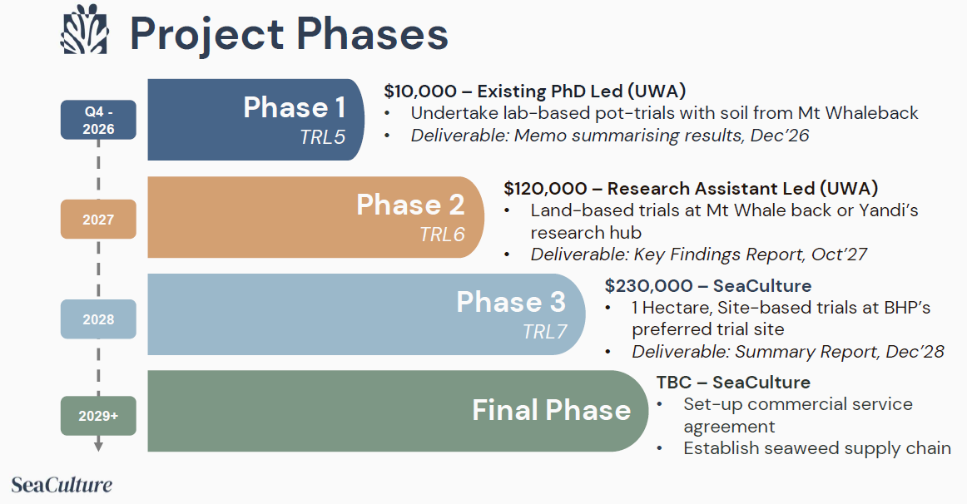

  - How does a new seaweed-based approach to mine rehabilitation integrate with pre-approved rehabilitation plans? The lean canvas suggests the seaweed method will avoid a formal amendment to existing plans.
In the NT and WA, both mining regulators (i.e. DMIRS, EPA) measure the success rate of mine rehabilitation based on results rather than the approach undertaken by the operator. For example, revegetation of areas will be specified with respect to metrics such as the species type and vegetation density which will be specified in the original environmental approvals plan. There will be examples of recommended methods for achieving these targets such as the re-lay of topsoil but if these methods are unsuccessful, the mine closure will not be accepted by the regulator.

In states like WA there is also growing expectations from the regulator to trial new approaches to mine closure including investment into innovative techniques as those stated in original plans have been unable to meet regulatory requirements.

  - What is the key differentiator between the biostimulant and existing mine rehab products/ approaches used by industry?
Biostimulents are focused on the plants response to specific chemicals to enhance properties such as growth, photosynthesis and many others. Seacultures product is a soil improver (not biostimulent) designed to improve the availability of nutrients, adjust the physical properties of the soil through the addition of natural gels and increase the amount of organic matter in the soil. Mining operators typically use existing topsoil which was stored on site during operations which results in the organic matter in the soil decomposing with time. This means there is a limited amount of topsoil available for closure, usually resulting in a thin layer (1-2mm) being laid to cover the largest area possible however this directly affects the success rate of revegetation. This existing method is no longer being accepted by the regulator so new approaches such as progressive closure is being trialled to reduce the impact of the topsoil breaking down with time. Even with these methods, mining operators are unable to source sufficient topsoil to lay across their closure sites, resulting in an expectation for ongoing rehabilitation efforts.

  - What is the process of validating the agar byproduct to a market standard?
The main metrics are gel strength, texture and purity. Depending on the application of the agar, these metrics vary. See below an example list of a few different agar products based on their different profiles used by Java Biocolloid, a major agar producer based in Indonesia:
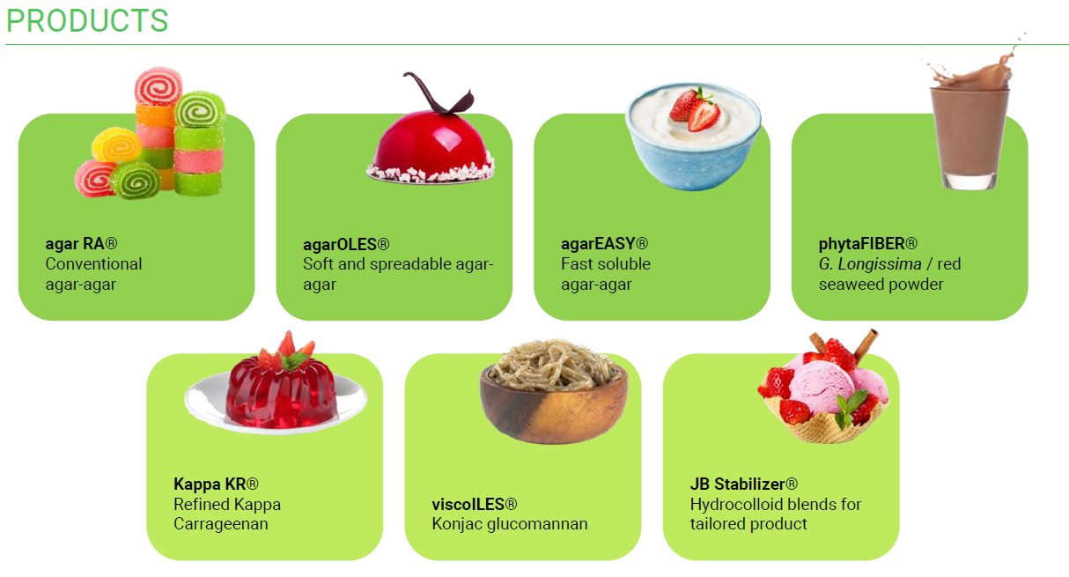
  - How many sites would be required to produce enough agar gel to get wholesalers/distributers interested?
Major operators such as Java Biocolloid produce 1500 MT/year of agar, but Seaculture is looking to partner with these types of organisations rather than attempt to compete with them as a distributor. Based on this, a single processing site which may be serviced by multiple small-scale seaweed farms should produce enough agar gel to service this type of relationship.

  - Have you spoken with any partners, offtakers for the agar product?
Yes, we visited Java Biocolloid in Europe (distributor) in January 2025 and in Indonesia (processor) October 2025 who were willing to discuss partnership opportunities once Seaculture is operational.

- Technology

  - What are the key factors you have considered for species selection North Australia?
- The species must grow locally, in abundance in the region where the seaweed hub is being proposed.
- The seaweed species must also have existing approaches to farming to streamline the set-up of each site (i.e. fragmentation of Gracilleria).
- There must be a local customer available for the bulk of the seaweed derived products (i.e. soil improvers for mining and agricultural)
- There needs to be multiple other product streams available for development to diversify the assets income streams

  - What data underpins the assumptions for the seaweed growth rates in the Process Model sheet?
The process model is based on Gracilleria with the potential for year-round harvest, approximately 4 times a year. This species has a short growth cycle of between 8 weeks to reach maturity which in theory could provide 7 harvests per year however this does not take into consideration the ideal age for harvesting to maximise growth rates and material quality.

  - How have prior lab-trials completed to date been setup to control for real-world conditions?
Soil trials have used samples from local farms in WA in areas of low productivity or an inability to grow anything successfully in the area. Based on each soil sample, the lab is set-up to reflect the light, temperature and watering conditions of the typical time of the year when seeding would occur. This provides the best baseline results before transitioning to field trials.

  - How do application rates of seaweed potentially differ from synthetics? Or are they roughly the same?
Synthetic fertilisers are typically focused on being the “food” for different crops/ plants an are laid at varying rates depending on farmer experience. Some farmers will overlay synthetic fertiliser to maximise crop density/ growth however the input costs can often outweigh the final profit of the increased tonnage of crop, others will use a lesser volume of fertiliser which impacts crop density but the significant reduced operational costs increase the net profit.

This type of comparison isn’t possible in the mining scenario as there is evidence that synthetic fertilisers can have a negative correlation to vegetation so they are rarely used by the industry. With this said, Seaculture’s seaweed derived product only requires between 5-8% blend based on initial trials, for the targeted area a specific seed is growing.

  - What are the different cultivation techniques you are trialling?
Fragmentation with different sample sizes, rope types, growth lines and depths depending on the specific environment but the plan is to transition to direct seeding once these methods are consistently growing at predictable rates during the wet and dry season.

  - What are the contingency measures for extreme weather conditions? (e.g cyclones)
This is relevant specifically for the growth infrastructure and processing equipment. For growth infrastructure, we are looking into designing adjustable lines which will allow the infrastructure to sink in anticipation of a cyclone, protecting the growth lines from any extreme storms. Companies such as Greenwave in New Zealand have been providing guidance on this challenge based on their infrastructure design for more intense oceanic conditions.

Additionally, as there is flexibility in harvest timelines, the seaweed can remain in the water for extended periods if the local community is recovering from a major weather event without any notable impacts apart from a delay in revenue/ changes to the site cashflow.

For our land-based infrastructure, we have designed our more expensive processing equipment to fit into a shipping container which can be locked away in the event of an extreme weather event. All installation of external buildings will be cyclone rated as per local construction standards.

  - Long-term, what other technologies could be integrated to improve cultivation, processing, and application?
Cultivation: unlocking direct seeding rather than fragmentation will reduce the manual intervention required for tying seaweed samples. Similar to the work undertaken for kelps.
Processing: additional purification stages could be added to the current processing technique to increase the value of product streams such as agars and pigments.
Application: reducing the reliance on human intervention for turning the soil and laying new seed for vegetation through semi-autonomous robots such as those being developed by companies like Quenda.

- UWA Relationship and IP ownership

  - Could you please clarify the IP ownership position in relation to your existing UWA relationship?
The only IP related to my PhD is the seaweed processing phases and pot trials associated with the seaweed derived soil product. As outlined in section 5 of “Intellectual Property Policy - UP07/49” that (A). Students will own the IP they create. The university Student Deed Poll also states that:

“UWA has no automatic legal right to intellectual property (IP) created by students during the course of their studies at UWA. However, in some instances students may be requested to reassign their rights to IP generated while participating in research projects using a ‘Student Deed Poll’ (the Deed). The Deed can be used when the project is funded by a third party, pre-existing IP is used by the student, or significant university resources are required by the student.”
I have outlined the ownership position and associated IP generated in the below:

For the BHP pot trials scheduled for November this year, the following IP trail can be followed:

  - How will you balance PhD candidate at UWA with Seaculture?
Current candidate status is Part-time as of 1st of April 2026 to allow me to focus on business development. The hours expected for a part-time, domestic PhD student are flexible but also linked to a core part of the business’s technology development. By remaining linked to UWA through my PhD I am able to undertake critical pot trials for clients at student rather then commercial rates and establish partnerships with local organisations such as CDU with ease. There is a process currently underway to assign a local CDU professor as an external supervisor on my PhD, providing ease of access to critical lab infrastructure for local NT project trials.

I can set-up a meeting with my supervisor to discuss this arrangement as required.
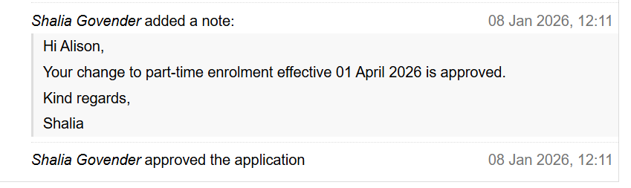

  - Has Seaculture received any independent legal advice to confirm the future IP ownership status?
Yes, we have spoken to numerous advisors including one former UWA commercialisation lawyers, one former ANU commercialisation lawyer and WRAYS group an IP specialist consulting group based in WA.

  - Would UWA be willing to provide formal acknowledgment of Seaculture IP?
A previous request has been made however the commercial lead at the time, Samantha Tough, no longer with the university as of August 2026, was unwilling to write a letter acknowledging this. A new request has now been made but irrespective of the response it’s the university policy is states in section 5 of “Intellectual Property Policy - UP07/49” that (A). Students will own the IP they create. The university Student Deed Poll also states that:

“UWA has no automatic legal right to intellectual property (IP) created by students during the course of their studies at UWA. However, in some instances students may be requested to reassign their rights to IP generated while participating in research projects using a ‘Student Deed Poll’ (the Deed). The Deed can be used when the project is funded by a third party, pre-existing IP is used by the student, or significant university resources are required by the student.”

  - A copy of the previous employment agreement executed with Canopy Blue
See employment contract section 13.1 which refers to “in the course of their employment” which ceased from 7th of April 2025. There is also mention of the NIPhD program which was the initial form of engagement, however Canopy Blue did not meet the financial terms set-out in the schedule 2 so the agreement is no longer valid. 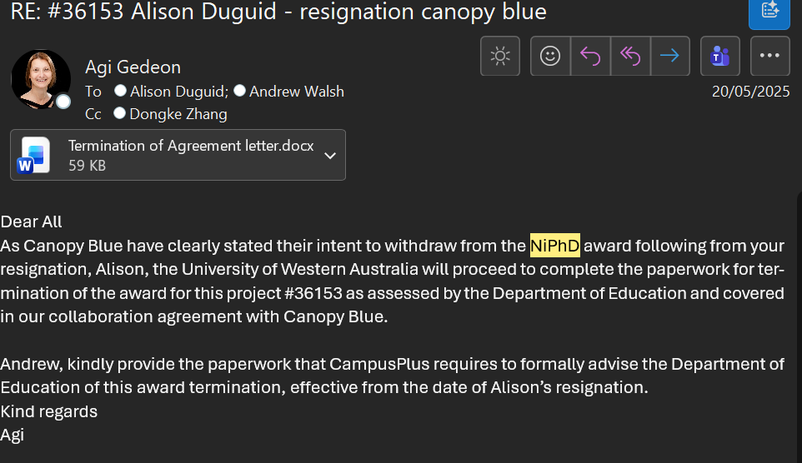

- Use of Funds
  - Noting round size could be more, could you provide a revised breakdown use funds for a $750,000 round in Sharepoint? (Similar to pitch deck).
I have updated the model with the following key changes:
- Two sites online in the next 3 years rather than three sites
- De-scoping agriculture project focus in the first two years to allow for a reduced number of employees
- Consulting/ project income with Maxima only for 2027 rather than new hires
- Holding a core team of 3 FTE in the first 3 years with the rest as contractors

  - What are the expected key milestones to be achieved after the runway has been expended?
5 year runway with no expectation to undertake an additional capital raise based on the following:
- Service contracts with local mining operators for their closure schedule
- Built 2 or 3 processing hubs (depending on capital raised)
- Hired a team of either 5 or 8 full-time equivalent employees depending on the number of operational sites
- Secured between 1-3 ocean leases & licences for commercial operations, starting with exemption licences in years 1-3
- Established commercial agreements with agar distributor
- Set-up/ run local training program including school-based STEM & seasonal internships with secondary and tertiary students

  - Roughly what proportion of funds would be allocated towards an NT site?
40% on infrastructure, 10% on intangible relationship development and 20% on local employment.

- NT Project
  - What is the latest status of the Darwin Waterfront seaweed growth experiments?
We are undertaking our 4th round of adjustments to the site on the 14th of October 2026 as the depth/ line sagging was making it difficult for the seaweed to grow in competition with microalgae in the water. With this said, we have had over 50% success rate for the growth of each of the seaweed plants in the lagoon, with staged plans to have the entire structure populated by the end of the year. The team is currently drafting a proposal for expansion into another section of the lagoon where our target seaweed species naturally grow more successfully and allowing for a larger footprint to service planned field trials in 2027.

See bellow example results from trial phase 1 which shows significant growth in the first 14 days followed by a decline in growth in the following 7 days. This is an expected result with other interfering factors such as local fish, heavier material naturally fragmenting to make new plants and operator interference due to manually removing the seaweed from the water to measure them.

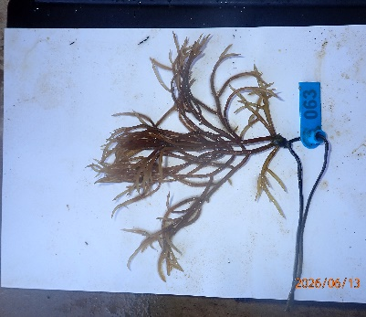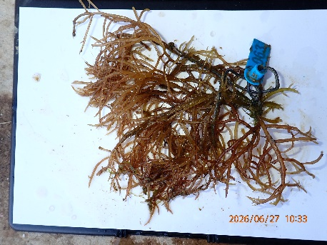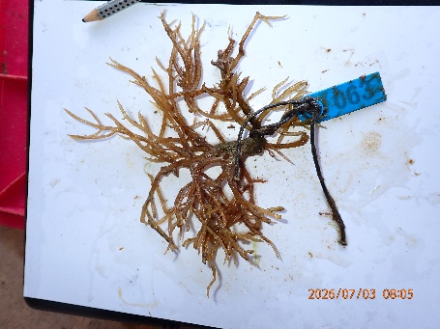

  - Current status of Rio/Gove conversations? Has there been any update since August?
No update from Rio Tinto however we are looking at other angles to get engagement from the mine closure lead through our local partners (i.e. DEAL, Layhna & NEAL) as well as lead with the CRC-Time and NTG Mines and Energy team.

We have been working on a paid agriculture trial with the DEAL team in relation to an existing mining area being managed by Rirratjingu Aboriginal Corporation (RAC). Similar to the BHP trial this will start with a lab based pot trial using material from the Darwin Waterfront Lagoon project. Depending on weather restrictions in getting samples from Gove to CDU, this is projected for January 2027.

  - What is the next step forward for progressing South32/GEMCO Mine field trials?
Gain approval from South32 and Alyangula Land Council (ALC) to do a site visit to assess both the potential for seaweed growth sites & soil rehabilitation programming. ALC have verbally been invited by the new CEO to visit but we are looking to arrange a time that suits their team. South32 have indicated that during that visit they could arrange for a bucket of soil to be transported to CDU for put trials however payment for these trials have not been agreed upon. Seaculture aims to have this site visit completed this year so pot trials can commence Q1 2027.

Transition to field trials will then be limited by the access of seaweed biomass being grown locally, processed and then available for further paid trials. Comparatively, South32 (Groote Eylandt) have been more engaged in trial conversations then Rio Tinto (Gove) but they have more complexities in traditional owner approvals for the project as we were advised earlier this year. To proceed we will need to submit a “ALC Research Permit” which includes detailed terms and conditions related to IP (see DD Supporting Docs Folder).

  - Who is the USA startup referred to for trials in Groote for the South 32/GEMCO Mine Closure?
Impetra are investigating their bacterial-assisted leaching for low-grade Mn material with us, focused on GEMCO:
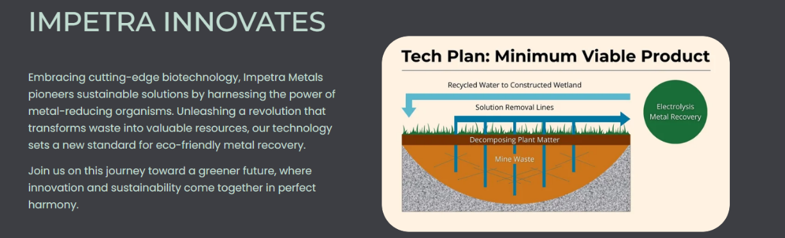
This start-up is semi-irrelevant as they were looking to use Seacultures seaweed biomass at low cost for their own innovation model which does not align with our business plan in the first 5 years of operation.
  - What other options could Seaculture undertake to complete field trial in Gove/Groote area without immediate miner involvement?
Both locations are looking into alternative industries such as agriculture as they have ongoing supply chain risks to critical areas such as food supply. In the Gove/ Nhulunbuy region, DEAL have shown interest in paid soil trials for their local agriculture projects which are being planned for the next quarter.

As the processing will also product agar gels & pigments, there are opportunities to begin working with the textiles, local cosmetics and arts industries to undertake local trials with our product streams

There are also opportunities to focus on the growth sites & processing sites for raw biomass sales to organisations such as Uluu, a WA based company interested in local Australian Gracilleria for their bio-plastics productions.

  - Could you clarify the nature of potential engagement with CDU? (e.g lab-use) How would it be formalised?
There are two phases for this engagement.

Phase 1: (2027-2028) utilising my PhD at UWA, there are active discussions around setting Dr. Vinuthaa Murthy - Associate Dean of Research as an external supervisor which will make it easier for local pot trials to be undertaken with biomass from the Darwin Waterfront Lagoon. This agreement will be established by the end of this year. This will allow for access to the local labs where UWA is charged a small “bench fee” for a visiting PhD student. This will include material characterisation which is important for some of our customers including those in agriculture.

Phase 2: (2028+) establishing a commercial agreement between Seaculture, CDU, UWA and the North Australian University Alliance. Dongke Zhang (my primary supervisor) is the engineering school representative for the North Australian University Alliance and is in support of this type of arrangement being established. This would be targeted to be signed-off by Q1 2028 once the research being undertaken transitions away from core PhD pot trials & processing. The intent would be to continue the research into seaweed derived products with associated university experts to assess locally sourced material at our target sites (i.e. Gove, Groote, Koolan Eylandt, Pilbara, Darwin)

  - Could you clarify the nature of potential engagement with CSIRO Berrimah?
20th of August 2026 with Tim Perrin who runs the Aquaculture in Schools program and 28th of August 2026 with Liz Crompton who leads program development and engagement programs. In these meetings there was discussion of the use of existing labs in Berrimah and current proposals with the Federal Government to establish a Aquaculture Hatchery just outside of Darwin to service emerging industries such as seaweed, prawns and tropical rock oysters.

Recommended next steps is to apply for the CSIRO kick-start program which would provide dollar-matched funding of $20,000 to $60,000 to help investigate challenges, refine concepts and move ideas closer to market. Before proceeding with this application, a lab tour at the CSIRO Berrimah site is being arranged for October 2026 (delayed due to the lab manager being sick after Croc Pitch) to understand what instrumentation they have access to which would be useful for Seacultures technology development.

  - What efforts have been made to date regarding site inspection in the NT for cultivation and processing?
From the point of inception in July 2025, desktop site selection was undertaken across the NT and northern WA based on economic profile, governance structure and existing aquaculture operations. This identified multiple possible coastal communities across the NT which included two high-priority regions based on existing mine closures in Gove (Rio Tinto) and Groote Eylandt (GEMCO). Since then, Seaculture has visited Gove twice to build local relationships and plan site inspections of possible cultivation sites in the region. There have been numerous efforts to undertake similar site visits in Groote Eylandt but the local aquaculture team advised at the time that there wasn’t capacity to have these conversations.

To help accelerate soil trails and growth techniques for local species of Gracilleria, trials have already begun at the Darwin Waterfront Lagoon which has led to multiple invitations to lower priority regions for seaweed hub development (i.e. Wadeye, Tiwi Island, Dundee, Managrida)

  - Other than Capex, what other resources and approvals would be required have in place to develop a biorefinery in the NT?
- Land Use and Planning Approvals. This will be different depending on each location
- Solar system under 2MW – no known special approval
- NT EPA. Submitting a licence application for any seawater inlet / outlet and land based footprint of the site
- NT WorkSafe notification & planning – Health and Safety including Registration of Plant Design:
- There are also additional approvals required for each of the product streams being developed in parallel to the primary soil improver i.e. food grade licencing for agar products

- Project economics
  - What evidence is there to support AUD XXXX per tonne for biofertiliser product? Same with Agar
Please see below links to reference reports in DD – Supporting Docs
  - What line-items is lang factor making up for that is not explicitly captured in the model?
See meeting minutes from in DD – Supporting Docs “SeaCulture Cost Meeting (20260922)”

- Team
  - Why have you partnered with Drift Consulting?
Drift is a consultancy specialising in expert advice on seaweed cultivation and farming techniques, and conducting independent, industry-ready research. They have experience in working closely with many Australian and International seaweed growers, conducting providing advice to, and independent research for, over eighteen companies world-wide. Margie and Michael Rule are both principal scientists holding PhDs in Marine Science, with over 20 years combined experience in a variety of roles focused on the diversity, biology, ecology and cultivation of seaweed. Margie Rule is a marine phycologist and aquaculturist, with specialist capabilities in the fields of seaweed biology, ecology and cultivation, and was instrumental in the establishment of commercial marine and land-based farming of Asparagopsis for two of the major growers in Australia. Michael Rule is a marine ecologist who specialises in ecological field research and has an interest in innovative and novel farming technologies.

There are limited marine biologists in Australia who specialise in seaweed cultivation and have experience working with commercial operators locally and internationally. Drift have provided critical decision making support on how to set-up local trials which will be viable to scale in local regional areas. They are also very well respected in the industry, regularly bringing new collaboration and funding opportunities to SeaCulture based on their existing network.

  - What is the nature of the engagement with Drift Consulting? (e.g Contract with Retainer or hourly rate?)
Currently a hourly rate based on a project by project basis.

  - What is Drift Consulting providing advice on specifically? And is it different subject matter from the MOU?
They provide advise on how different seaweed species have been successfully and unsuccessfully farmed across Australia with knowledge gained from their PhD’s and collaborations in South East Asia. For example, they drafted a “Gracilleria Cultivation Summary Report” detailing different methods of cultivation which SeaCulture has begun adopting for our trial in the Darwin Waterfront Lagoon.

  - What is the current level of engagement with Drift Consulting? (e.g daily, weekly etc.)
Prior to our deployment of the Darwin Waterfront Lagoon Project (i.e. June 2026), 8 hours a week was agreed between both parties to support both the planning & delivery of this critical project. Since then, we speak weekly on the progress of the site which is being managed by a local marine biologist company Pandora Expeditions.

  - Is there anyone else who will provide technical or scientific expertise over the next 12 months?
Locally in Australia there are limited options which is why we are focusing on kicking-off a project with our partners in BRIN and University Nusa from Indonesia who can continue to provide this support. This will allow us to have flexibility on who and how we engage with experts in seaweed cultivation.

We have also entered a short 6 month contract for 8 hours a week with a NT local marine biologist from Pandora Expeditions. This engagement is focusing on the ecosystems services associated with seaweed farming as well as learning about the techniques associated with seaweed farming.

  - Could you provide the job descriptions for the NT-based project manager and community engagement lead?
NT Project Manager: Responsible for delivery of key milestones associated with our growth, processing and product development projects in the NT. This includes:
- The commercialisation of our growth trials at Darwin Waterfront Lagoon including trials with new species which can be used for applications such as cosmetics, pharmaceuticals, edibles and other streams
- Delivery of our first processing unit including negotiations for cost savings via the use of local mine closure equipment
- Local stakeholder management associated with sites across the NT including traditional owner organisations, customers and collaboration partners
- Tracking & updating quarterly budgets, milestones and reporting
Community engagement lead: responsible for the delivery of education, training and upskilling programs. This will include
- School-based STEM programs such as site visits, challenges and internship programs
- Ranger/ community-based education about seaweed cultivation, processing and product applications
- Establishing a presence at key community events such as annual AGM’s, conferences and networking events
- Identifying and establishing partnerships with community leaders who will advocate for seaweed hubs across the Territory, including joint grant application opportunities
- Identifying mechanisms for ownership transfer that represent community interests once each site is ready to transition to a franchisee model. This could include employee buy-back schemes, organisations investing in the initiative, long-term royalty programs or other options which can viably be adopted by the associated community

- Partners

  - Can go through later.

- Other

